MSI IDC Kodiak Access Control

Document Version Control

Version | Revision Reason | Author | Approver | Date
V0.1 | Initial Draft | - | Gora | 3/2/2021
v0.2 | - Updates based on internal audit feedback observations  - Updated the template, removed document # and outdated version details from header  - Updated the control number in the headings to version 2022 of ISO27001  - Added A.5.14, A.5.17  - Moved A.8.2, A8.4 to Bangalore-MSI-Kodiak Technological Controls - Operation Security | Moses George | Manjunatha R  Amitraj Deb | 23/07/2024
v0.3 | Removed kodiak Jira from the local Bangalore IT scope, kodiak Jira has limited access to just IT admins and will be decommissioned in Q3-Q4 2025 | Moses George | Manjunatha R  Amitraj Deb  Lakshmikanth Mannepalli  Krishna Prasad M V | Aug 15, 2025

Table of Contents

Document Version Control 2
Table of Contents 3
A.5.14 Information transfer 4
Information transfer policies and procedures 4
Agreements on information transfer. 4
Electronic messaging 4
A.5.15 Access control policy 4
Access to networks and network services. 5
A.5.16 Identity management 6
A.5.17 Authentication information 6
A.5.18 Access rights 7
Review of user access rights 7
Removal or adjustment of access rights. 7

A.5.14 Information transfer
- We are using G-Suite for all information sharing, and it is protected via multi factor authentication.
- G-Suite is used for within and external communication as well.
- This is inline with MSI Corporate.

Information transfer policies and procedures
- This is MSI Corporate

Agreements on information transfer.
- This is MSI Corporate global agreement with Google.

Electronic messaging
- MSI Corporate

A.5.15 Access control policy
- All Kodiak information technology (IT) resources that store, process, or transmit Confidential or Protected data must require usernames and passwords for access.
- Data Business / Service Owner must authorize all individuals prior to their accessing IT resources that store, process or transmit Confidential or Protected Data.
- Individual users are responsible for developing and implementing procedures for authorizing and granting access to their IT resources that store, process or transmit Confidential or Protected Data.
- Data Custodians shall document all data access privileges, and will reevaluate access privileges when a user’s job assignment changes. When a user no longer requires data access or leaves the Kodiak for any reason, the Data Custodian shall request/revoke the user’s access privileges. The user’s supervisor is responsible for making appropriate and timely requests to the Data Custodian for IT resource account access modification.
- Individuals with access to Confidential or Protected Data may not share or redistribute this data without receiving the expressed, prior consent of the Data Custodian.

Access to networks and network services.
- Users will be given access to network and network resources using the central authentication system of Active Directory/Radius/LDAP Authentication.
- Users will be given the access on need to know basis policy.
- Privileged users will have access to network devices with RADIUS authentication in place.
- All VPN Access to the network is also given through Central AD Authentication Servers.

VPN Connection
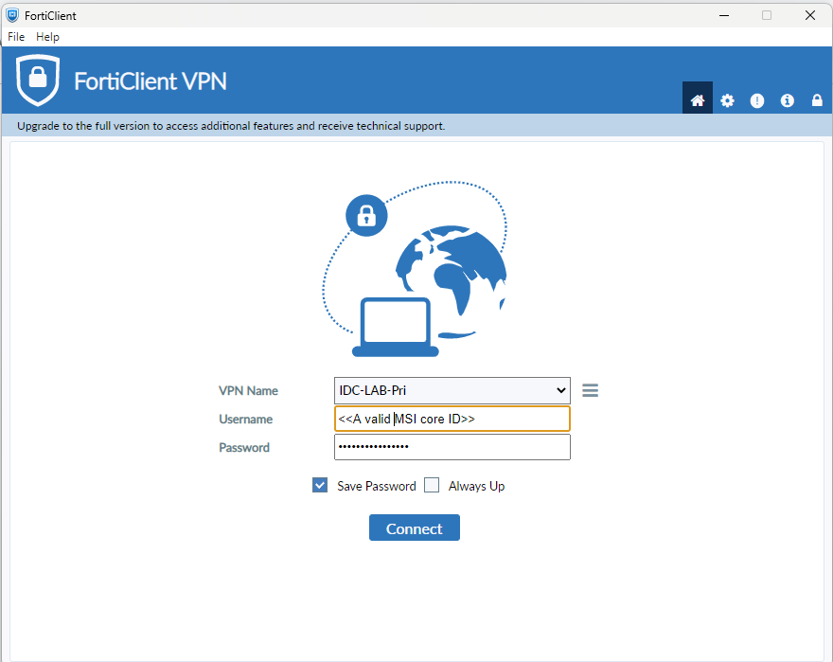
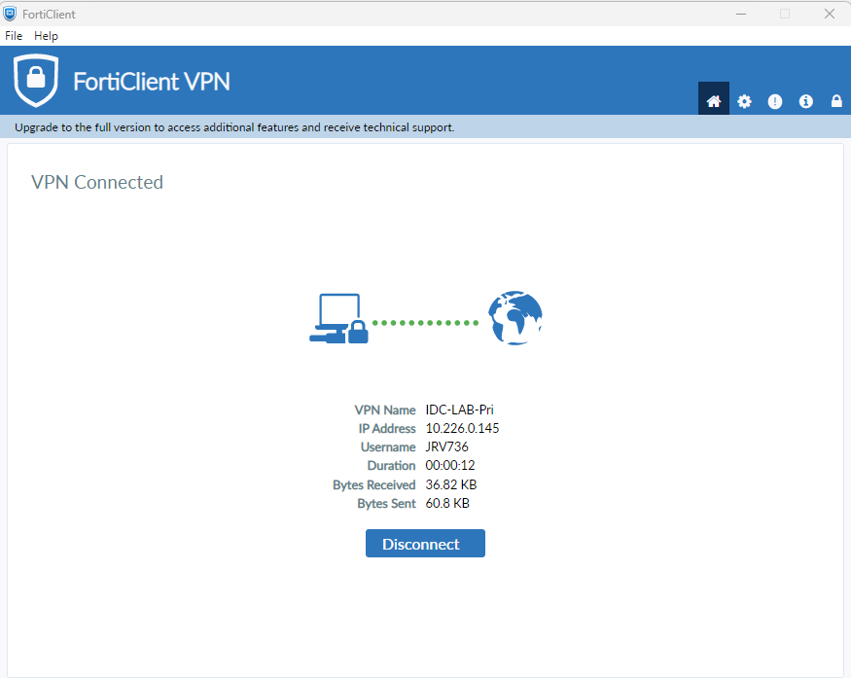

A.5.16 Identity management
- Any new user request will be raised through Servicenow Portal, with manager’s approval attachment.
- Users will be provisioned by the IT Team, and the initial temporary password will be shared with the user or with his supervisor in one - one mail.
- If any users are moved or roles have changed or leave the company, the respective manager has the due responsibility to communicate the same and the IT team will remove the respective user.

A.5.17 Authentication information
MSI Corporate authentication - Access to all Corporate MSI tools and assets is through a valid MSI core ID and Password set as per MSI authentication policies.
- MSI Core ID and Email ID Creation - Covered by employee onboarding
- New users Azure GIT Repository, Process
- New user MSI Jira is controlled via MSI mot AD
- All users' passwords are stored on Active Directory with MD5 authentication.
- All users are forced to change their passwords for every 90 days

Administrators
- Lakshmikanth M, Madhurya Soma [IT-Local] - kodiak AD
- Krishna Prasad, Gudla Venkataiah [DevOps] - GIT repo
- Global MSI IT - All other MSI Tools Management

A.5.18 Access rights
- Users will be provisioned on Active Directory which is in turn integrated with all Kodiak Bangalore locally hosted applications, network, Printing and VPN Solutions.
- For MSI applications and tools, User’s valid MSI Core ID will be provisioned on MSI mot Active Directory.

Review of user access rights
- Audit/ Pruning of all users will be done by the IT team and respective access control managers/administrators every 6 months to make sure that we have only valid users.

Removal or adjustment of access rights.
- If any users are moved or roles have changed or leave the company, the respective manager has the due responsibility to communicate the same, and the IT team and respective access control managers/administrators will remove the respective user IDs.

